Objective | Exemplary  4 | Above Proficient  3 | Proficient  2 | Novice  1 | Score
Student knows and understands fractional terminology such as denominator, numerator and whole and shows this knowledge through his or her answer key. | Student provides labeling of fractional terminology and provides a varying list of fractions that are labeled by the fractions design or other explicit symbol. | Student provides an answer key that explicitly reveals fractional terminology and has fraction numbers labeled by denominator and numerator. | Student’s answer key provides the correct written fractions of the coordinating squares and correctly represents the fractions as a whole. | Student provides an answer key but does not contain the correct representation of fractions or is unreadable.
Student is capable of dividing each square into equal fractions of eighths, sixths, thirds and halves. | Student divides each square equally using eighths, sixths, thirds and halves while also adding additional squares or divisions of more difficult fractions. | Student divides each square into eighths, sixths, thirds and halves equally while recognizing each square as a fourth. | Student divides each square into eighths, sixths, thirds and halves equally. | Student does not provide squares with eighths, sixths, thirds and halves or any fraction with equal parts.
Student shows understanding of his or her kite squares are all parts of a whole and represent a variety of fractions. | Student recognizes each square as a fourth of the kite and uses a variety of fractional representations in each square. | Student recognizes each square as a part of a whole and correctly uses fractions to display this knowledge. | Student correctly represents his or her kite as a whole using the required fractions. | Student does not show understanding of the squares representing a whole and does not display fractional variety.
Student uses different techniques and art media (such as colored pencils, drawing and collage paper) to create a variety of fractions. | Student provides exceptional designs and artwork that is “outside of the box” and represents each fraction individually. | Student uses additional materials and techniques outside of the classroom that express creativity to represent each fraction. | Student uses provided art materials to create a multitude of designs to represent each fraction. | Student uses art materials to create designs to represent each fraction but repeats designs over and over.
Student creates a visual art representation that is neat, readable and communicates the understanding of fractions as a whole. | Student creates an elaborate kite that displays a large variety of visual representations that expresses information through the visual.  Name:  Comments: | Student creates a kite that reveals strong visual representation and show extensive knowledge of fractions as a whole. | Student creates a kite that is easily read and understood with visual aid. | Student creates a kite that provides little visual or information that is not easily read or understood.
Total Score:
Grade 3 Mathematics
Standards:
- 3. NF.1Understand a fraction 1/b as the quantity formed by 1 part when a whole is partitioned into b equal parts; understand a fraction a/b as the quantity formed by a parts of size 1/b.
- 4.1.2 Know the different techniques used to create visual art
- 4.1.5 Know how different visual art media techniques and processes are used to communicate ideas, experience and stories

Performance-Based Assessment Lesson: The students will each be given four square-shaped sheets of paper that needs to be divided by them into eight, six, three and two parts. Once the students divide one square to each of these fractions, the students will color and design the fractions of their wholes to create a variety of fraction possibilities. An example would be the following:

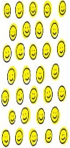

Once the students create their fraction varieties in each square using markers, colored pencils or construction paper, the students will create an “answer key” corresponding with their fractions. If they divided up one square into thirds, they will write that 1/3 is polka dots, 1/3 is stripes and 1/3 is smiley faces. If divided up into sixths, 2/6 is zig-zags, 3/6 is purple and 1/6 is swirls. After each square has been completed, the students will place their squares together to form a kite shape, including the string of the kite. Inform the students that they also form a whole divided into four parts. The students will place their fraction kites along with their “answer keys” on a display board in the hallway of the school titled, “Flying with Fractions”. This way students create their own fractions with their designs and are required to identify eighths, sixths, fourths, thirds and halves using a real object and visual arts.
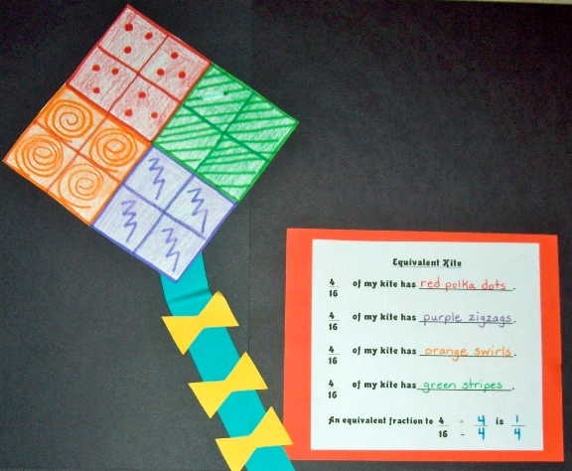
Picture Example:

